**PREDICTING PERSONAL LOAN APPROVAL USING MACHINE LEARNING**

**TEAM LEADER TEAM MENTOR**

V.R .SUSHMA LALI Dr.E.ELAKKIYA M.Sc., M.Phil., Ph.D.,

**TEAM MEMBERS**

R.SOWMIYA

S.SUVITHA

P.SRI ISHWARYA

**1.INTRODUTION**

Many banks' primary line of business is loan distribution. Loans given to consumers account for the majority of a bank's revenue. These banks charge interest on loans given to customers. Banks' primary goal is to put their savings in dependable clients. Many banks have been processing loans so far following a backwards process of vetting and verification.

But, as of right now, no bank can guarantee whether the customer who is selected for a loan application is secure or not. In order to avoid this circumstance, we developed the Loan Prediction System Using Python, a system for the approval of bank loans.

* 1. **OVERVIEW**

All of these loans cannot be approved. Loan gains are the primary source of income for bank assets. Banks' primary goal is to put their savings in dependable clients. Many banks today authorize loans after extensive verification and validation procedures, yet there's still no guarantee that the chosen customer is secure. Thus, it is crucial to use a variety of approaches in the banking industry to choose customers who make loan payments on time. In this paper, we classify the data using the random forest algorithm.Using a trained dataset, the forests method creates a model, which is then applied to test data to produce the desired result. A lender is an amount of money that is taken out and then paid back over time, usually with interest. Individuals and corporations can apply for a variety of loans, including personal loans, mortgages, vehicle loans, school loans, and business loans. Banks, credit unions, and other financial institutions provide them, and the terms of the loan, including the interest rate, repayment schedule, and fees, varies based on the lender and the type of loan.

A personal loan is a kind of unsecured loan that can be used for a range of costs, including debt consolidation, house repairs, and medical bills. The lender and the borrower's creditworthiness determine the loan amount, interest rate, and repayment time. Borrowers normally need to show proof of income and have a strong credit score in order to be approved for a personal loan. By examining a borrower's financial information and credit history, machine learning can predict if a personal loan application will be approved. This can make it easier for financial institutions to decide which loan applications to approve and which to reject.

* 1. **PURPOSE**

To determine the loan status, several collections of information from previous loan applicants use various features. This data, which may be stable or time-series, can be examined by a supervised learning model to estimate the likelihood that the loan would be authorized. The capacity to precisely forecast loan approval based on applicant data is one of the business needs for a machine learning model to predict personal loan approval. Reduce the number of approved loans that default (false positives) and false negatives (rejected loans that would have been successful). To ensure compliance with rules and provide openness, it explains the model's choice.

Requirements for personal loans a good credit rating, expense record, income, low ratio of debt to income, enough collateral, possible origination charge.The firm should have a minimum yearly profit (ITR) of 1.5 lakhs per year. At the time of loan application, the applicant must be at least 21 years old, and at the time of loan maturity, they cannot be older than 65.

**2 .PROBLEM DEFINITION & DESIGN THINKING**

**2.1 EMPATHY MAP**

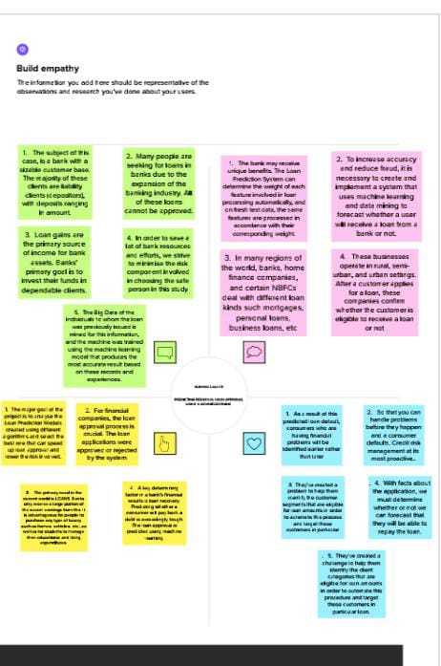

**2.2 IDEATION & BRAINSTORMIMG**

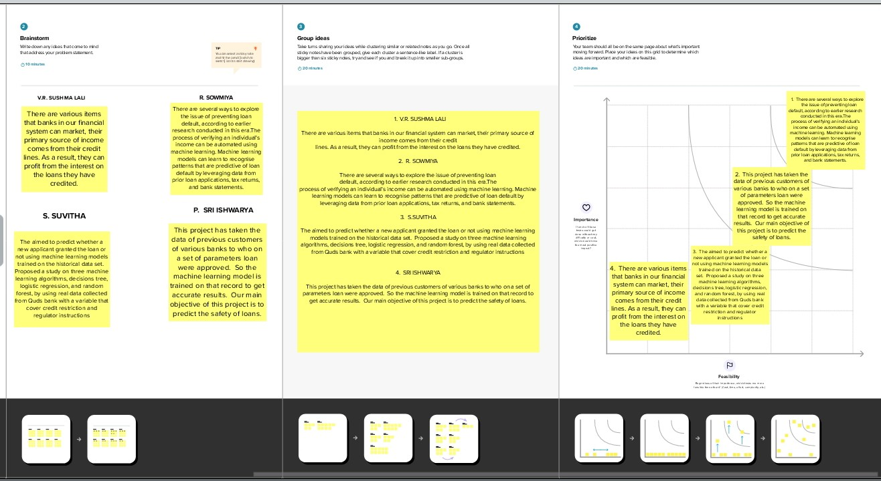

1. **RESULT**

**a)**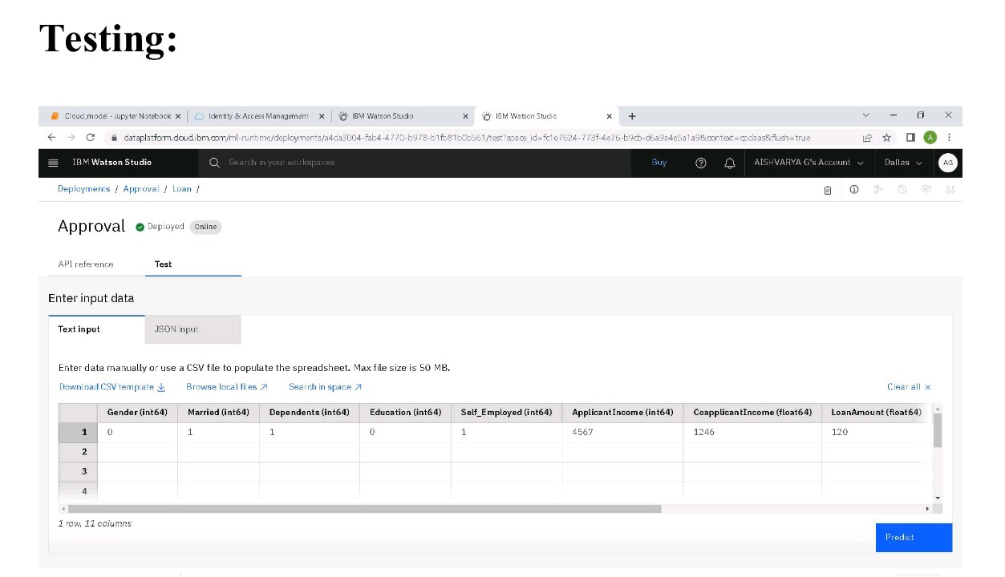

**b)**

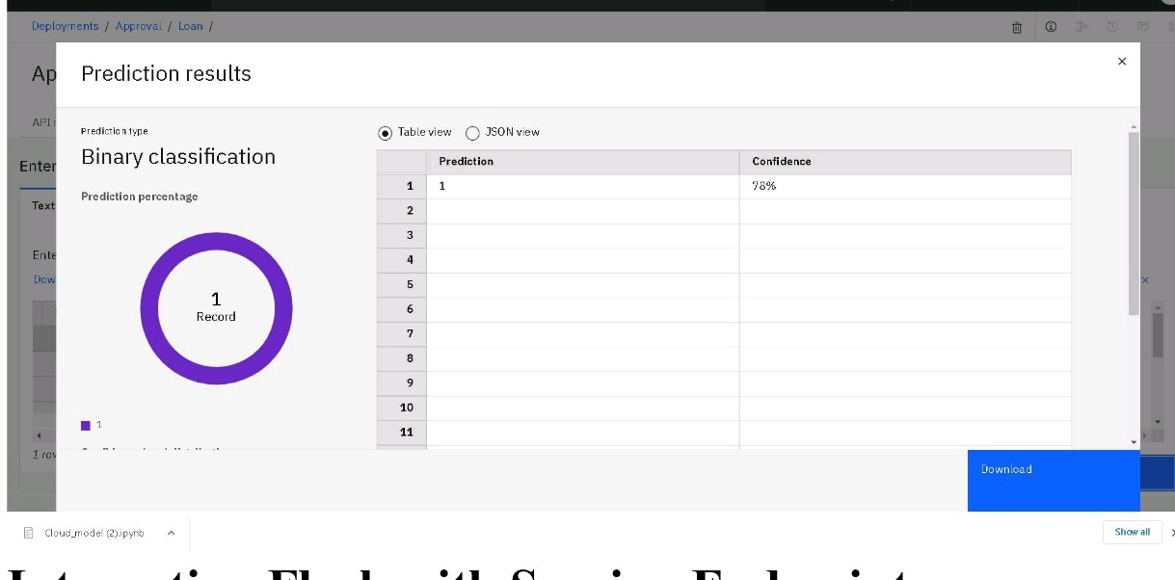

**c)**

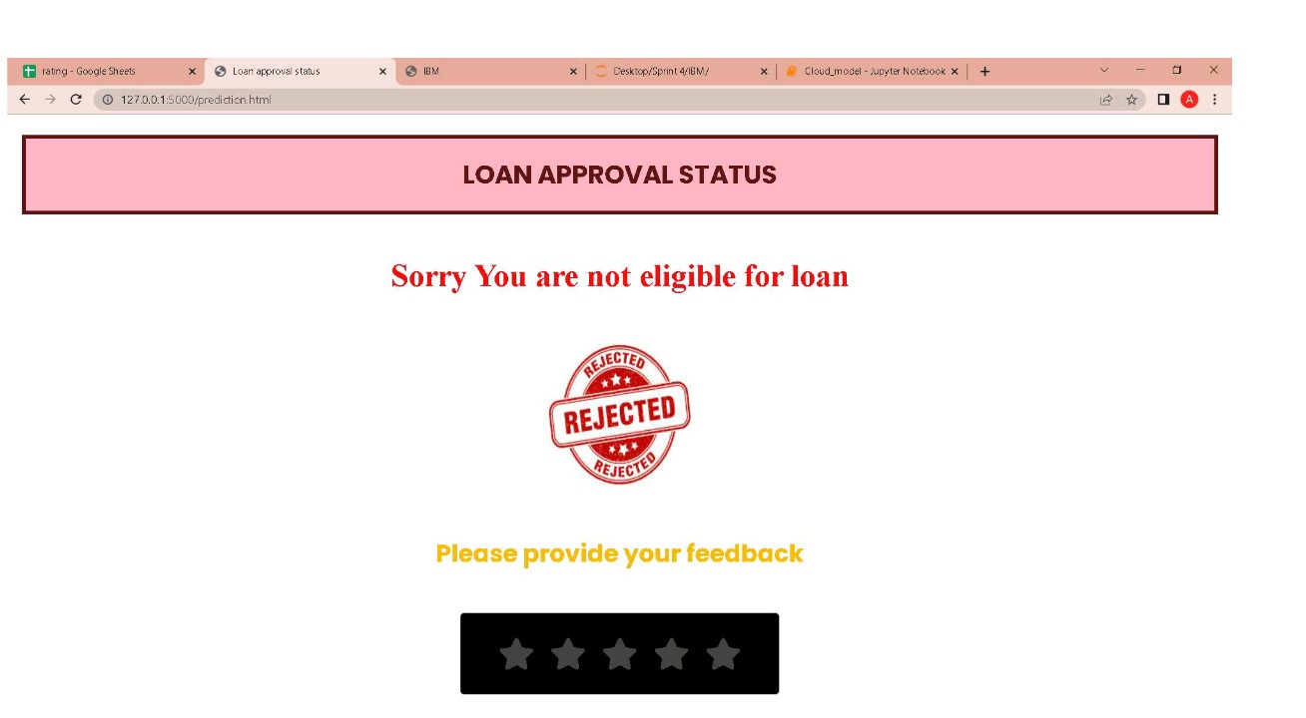

**4. ADVANTAGES & DISADVANTAGES**

On the basis of factors like credit score, income, age, marital status, gender, and other factors, it is determined if the loan can be granted to the individual. By lowering the risk and decreasing the number of defaulters, the prediction model benefits both the applicant and the bank.

   Bank loans often have the lowest interest rates. If you get a bank loan, the bank won't provide you a set of guidelines on how to use the money.   To obtain a loan from a bank, you are not required to forfeit any equity.

This model's weakness is that it emphasises distinct weights for each aspect, however in reality loans are occasionally accepted based solely on one powerful factor, which is not achievable using this approach. Employees of banks and applicants alike might benefit greatly from loan prediction

**5. APPLICATION**

The primary need in the current world is LOANS. Banks only receive a large portion of the overall earnings from this. It is advantageous for people to purchase any type of luxury, such as homes, vehicles, etc., as well as for learners to manage their educational and living expenditures.Yet, the decision as to whether the applicant's profile is pertinent for loan approval or not. Banks have a lot of responsibilities.

**6. CONCLUTION**

According to a good examination, this technique works perfectly for identifying customers who qualify for loan approval. All banking needs can be satisfied by the software, which operates flawlessly. With any operating system, this system is simple to upload. This approach has more potential in the future when technology shifts to the online realm. It is more dependable and safe to use this system. The Random Forest Algorithm that we utilised ensures that the system produces findings that are extremely accurate. If a large number of consumers request for loans, it won't be a problem. The data for N consumers is accepted by this system. We can expand this system's algorithmic capabilities in the future to get findings that are more precise.

**7. FUTURE SCOPE**

Both classification and regression tasks are efficiently carried out using the decision tree algorithm in machine learning techniques. Decision trees are produced. Due to their great accuracy and capability to express a statistical model in simple terms, decision trees are frequently utilised in the banking sector. Each node in a decision tree represents an attribute (feature), each link (branch) a decision (rule), and each leaf an outcome (categorical or continues value). It is possible to predict loan defaults and their severity using various data analytics technologies. To anticipate the type of loan, it is necessary to train the data using various algorithms, then to compare user data with trained data.

The data preparation and classification model building processes involved the usage of several R functions and packages. The result proves that the R package is an efficient visualisation tool that utilises data mining techniques. Using R Package, customer’s data analysis can be done and depends on that bank can sanction or deny the loan. Customers' data sets may have a lot of missing and imputed data in real time, and these missing and imputed data need to be updated with genuine data derived from the available finished data. The dataset comprises various parameters that define the credibility of the clients requesting for several forms of loan. There may be outliers in the numbers for these qualities that don't fall inside the normal distribution of data.

**8. APPENDIX**

**A. SOURCE CODE**

**Importing libraries**

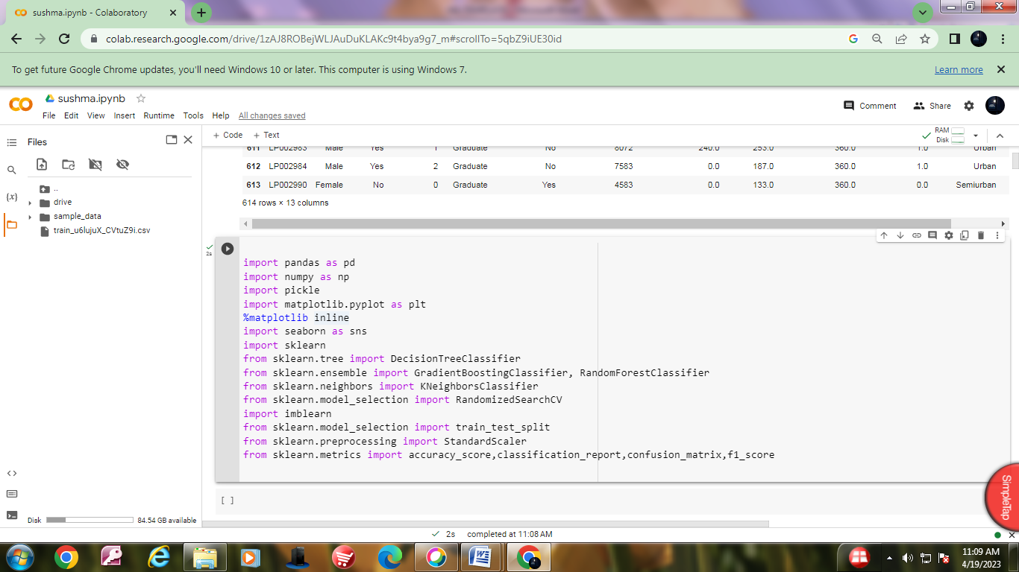

**Loading dataset**

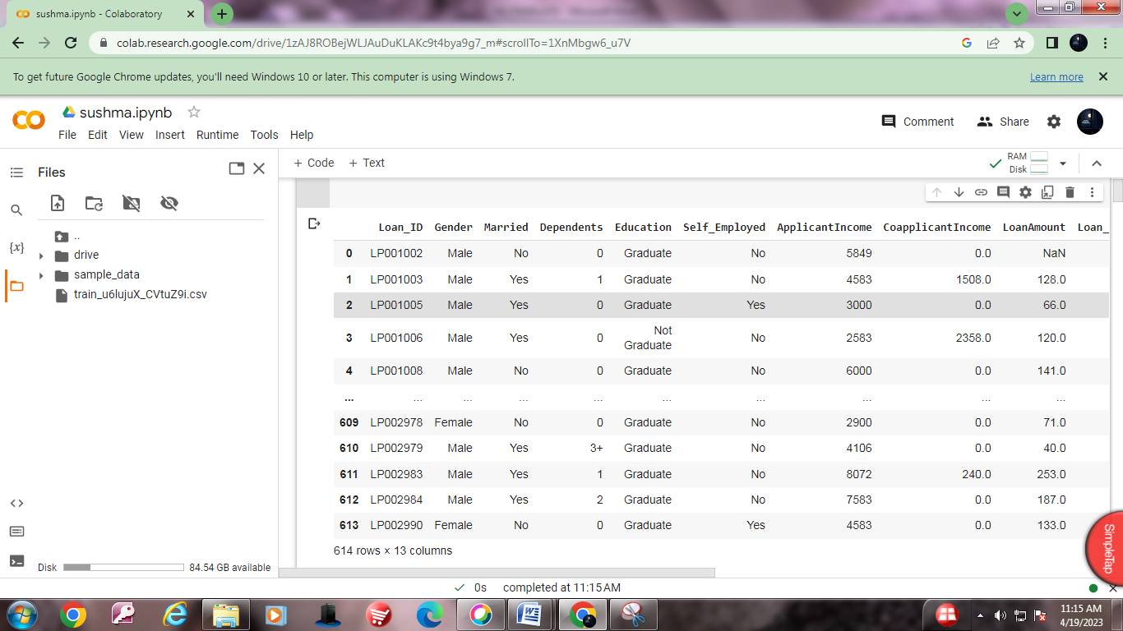

**Summary of dataset**

**Data info()**

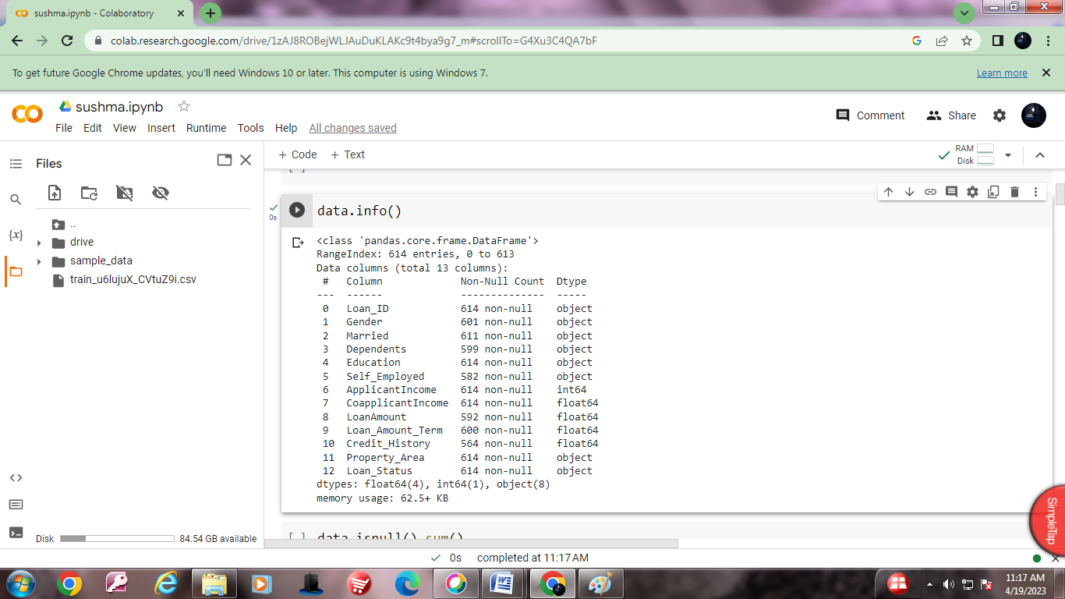

**Data.isnull().sum()**

